Proposed Projects

OF

Group Hub

Class Time Table App

- Mobile application that manages your daily classes and notify the user when its time for his/her class.

Rizal Educational Game

- can be a Mobile or PC 3D game that aims to teach the life of our national hero Dr. Jose Rizal. Integrating this to a game makes it more interesting for the students.

Human Anatomy App

- A mobile app that displays all parts of human anatomy, can be useful for medical students, can add AR feature for more interactive viewing.

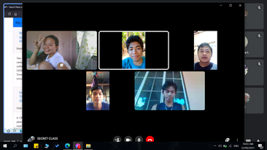

Members:

Lord Son Pabriga

R.A Patricia C. Corage

Glenn Gerald Dapitilla

Melchizedek A. Cruel

Bryle Anthony Montuya Orevillo